

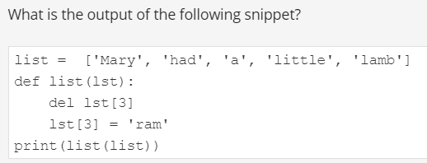

This snippet is erroneous



The None value may not be used outside functions

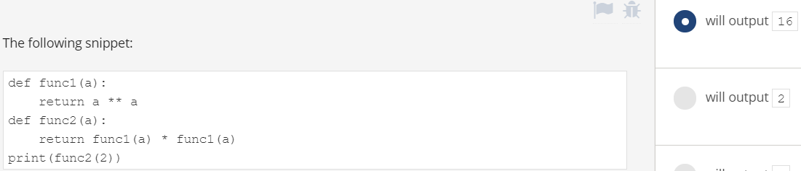

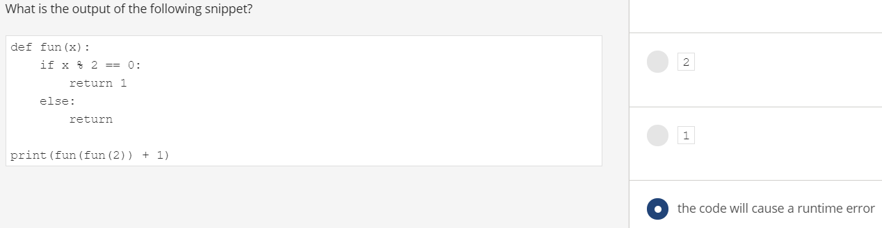

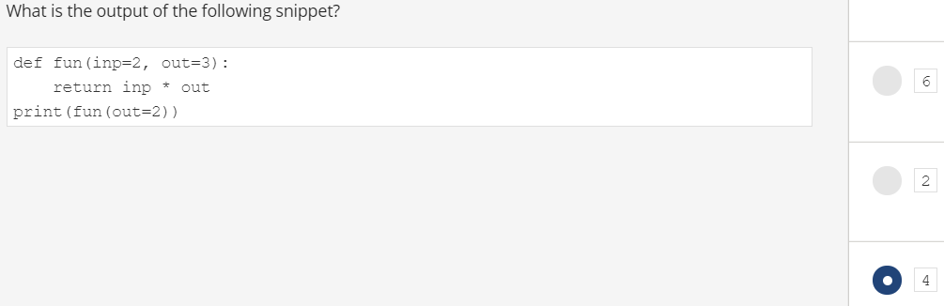

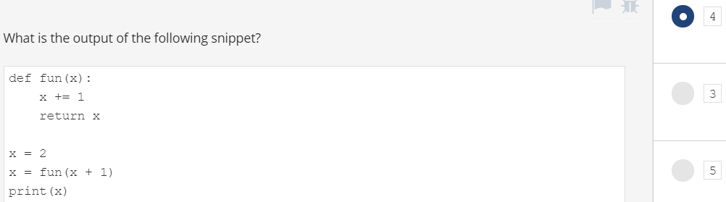

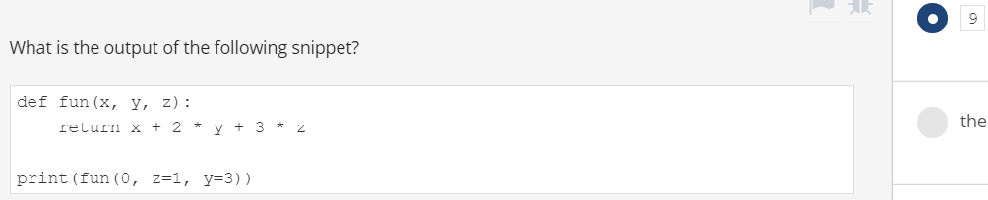

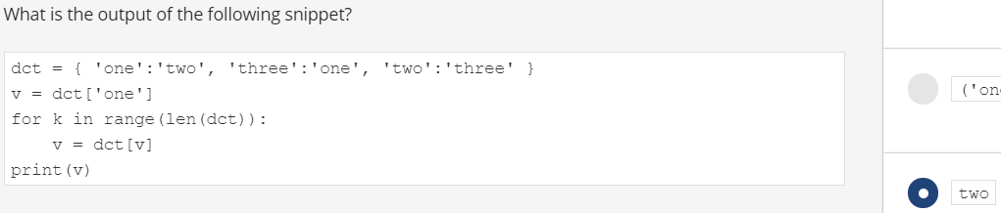

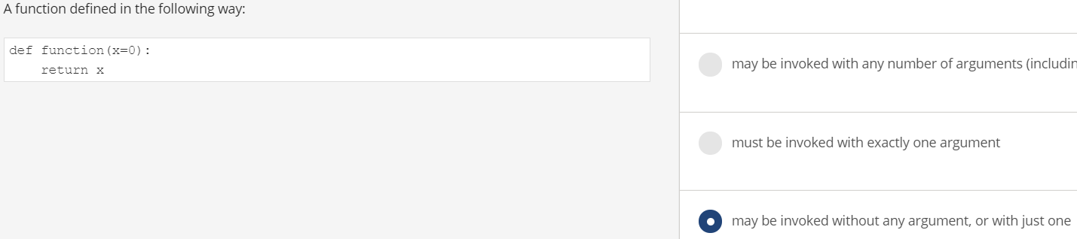

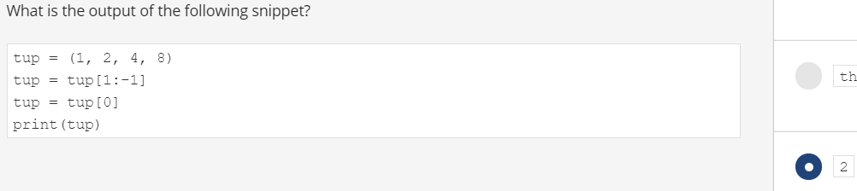

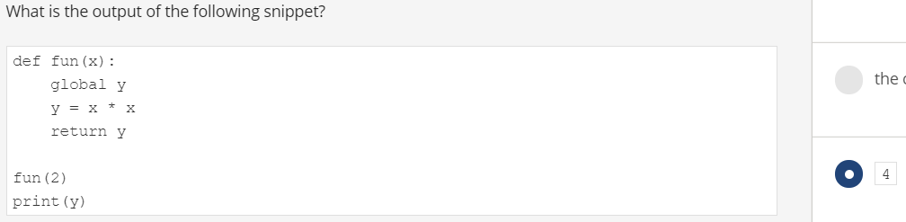

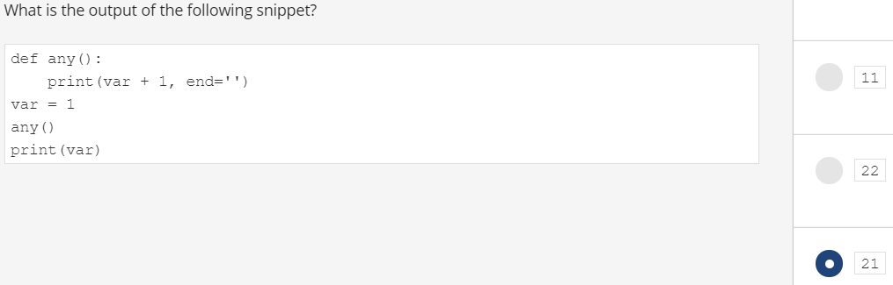

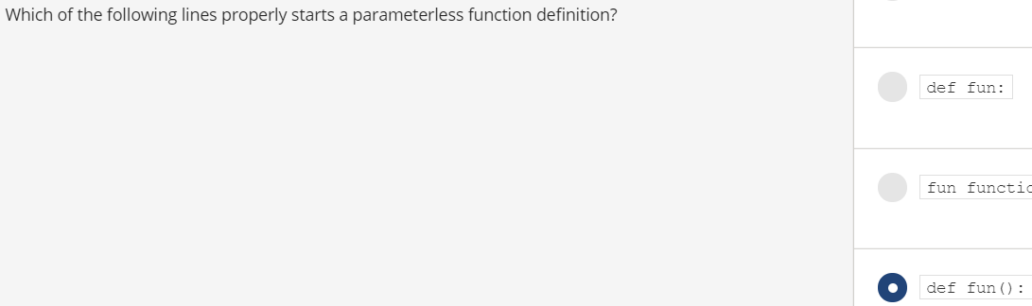

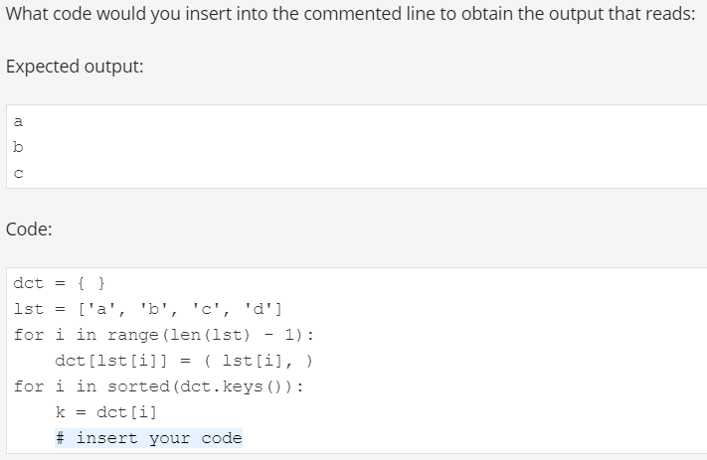

Print(k[0])

